John Lennon (1940-1980)

John Lennon was born in 1940 the 9 th of oktober in Liverpool, England. Johns growth was not so good. His parents separated when he was three years old. His dad, Fred Lennon tryed to take John away from his mother, Julia in 1945. But that faild Fred with. Julia understod that she don´t can take care of John so she sendt John to her sister, Mimmi. So hi lived with his auntuncle, Mimmi and George in Woolton, a pair kilometers from east Liverpool. Julia died in a carcrach in 1958. John don´t like the school. He hate the disiplin and the teachers.

Johns first band started in 1955 and the name of the band was “The Quarrymen” John playd the gittar. The band played “Skiffle”. But John woud play rock´n´roll as Elvis and Bill Haley. John lears to play when he listen on the radio. Paul McCartney start to play in the band 1957. In 1980 was John murded of a young crazy boy, Mark Chapman.

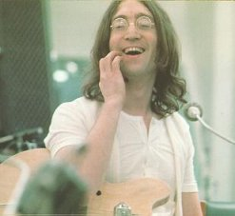

Av: Oskar Svensson 8E 26/9 2002

